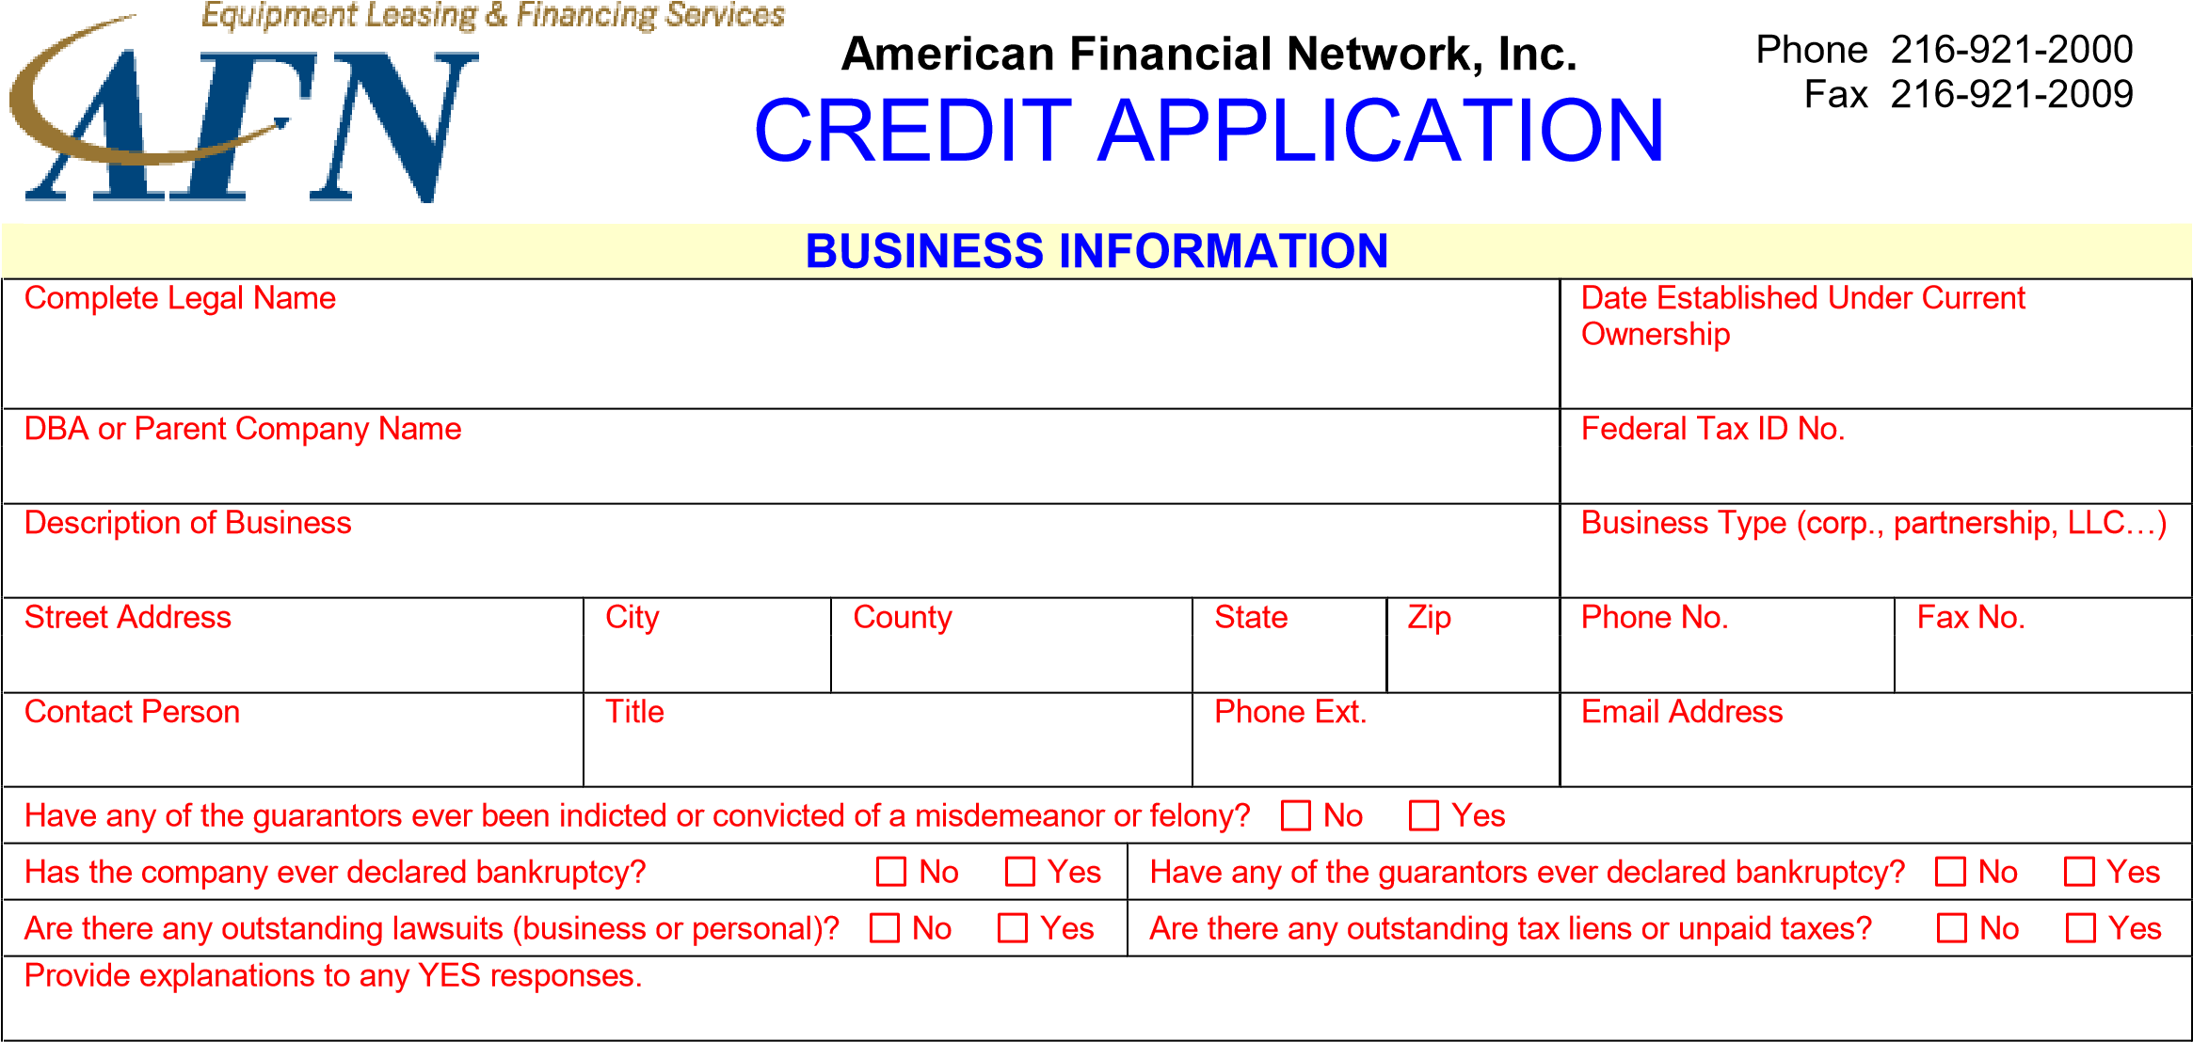
 |  | OWNERSHIP INFORMATION
Guarantor 1 (President/Owner) |  | Title |  |  |  | % Ownership |  |  | Date of Birth |  |  | Social Security Number
Guarantor’s Home Address |  | City |  |  | State | Zip |  | Home Phone |  |  |  | Cell Phone
Guarantor 2 (Additional Owner) |  | Title |  |  |  | % Ownership |  |  | Date of Birth |  |  | Social Security Number
Guarantor’s Home Address |  | City |  |  | State | Zip |  | Home Phone |  |  |  | Cell Phone
REFERENCE INFORMATION
Bank Reference :
 | Please make a copy of your most recent 3 months of business bank statements and include those statements along with this application.
Landlord |  |  | Contact |  |  |  |  |  |  | Phone No.
Insurance Agent |  |  | Contact |  |  |  |  |  |  | Phone No.
VENDOR & E |  |  |  | QUIPMENT INFORMATION
Equipment Vendor |  |  |  | Salesperson |  |  |  |  |  |  | Vendor Phone No.
General Equipment Description |  |  |  | Equipment Condition |  |  | Desired Lease Term |  |  |  | Approximate Cost
 |  |  |  | New Used |  |  |  |  |  |  | $
AUTHORIZATION SIGNATURE(S)
By signing below, each undersigned individual(s), who is either a principal of the credit applicant listed below or a personal guarantor of its obligations, provides written instruction to American Financial Network, Inc. or its designee (and any assignee or potential assignee thereof) or any lending source to whom this application is submitted authorizing review of his or her personal credit profile from a national credit bureau. Such authorization shall extend to obtaining a credit profile in considering the application of the credit applicant and subsequently for the purposes of update, renewal or extension of such credit and for reviewing or collecting the resulting account. I authorize all deposit, borrowing, and trade information to be released to the Lessor. I represent all information is true, correct and complete. Additionally, this authorization permits American Financial Network, Inc. or its designees (an any assignee or potential assignee thereof) or any lending source to whom this application is submitted to share and exchange information and to request, obtain, and review bank, financial or other information from past, present, or potential creditors. A photostatic or facsimile copy of this authorization shall be as valid as the original.
X ______________________________ X ______________________________
APPLICANT’S SIGNATURE (Required) CO-APPLICANT’S SIGNATURE Required)

Date : __________________ Date : __________________

